4. FOUNDATION

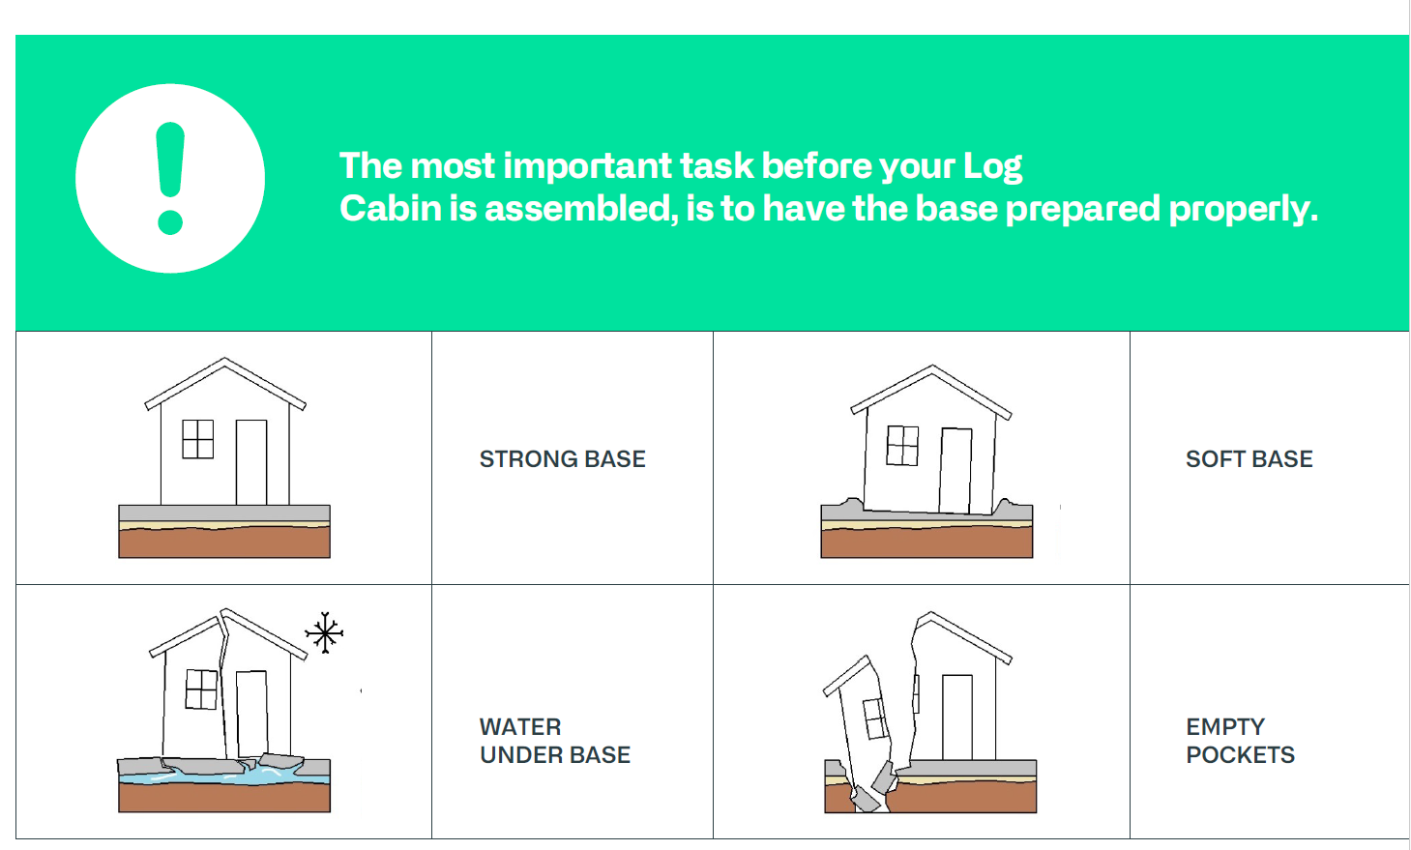

Foundation Problems to Avoid
- Strong Base ✅ - Level, stable foundation
- Soft Base ❌ - Uneven, unstable ground causing cabin tilt
- Water under Base ❌ - Poor drainage causes structural problems
- Empty Pockets ❌ - Gaps create instability and settling

Foundation Benefits
A properly prepared foundation ensures:
- Easy log wall assembly - Components fit together smoothly
- Proper door and window operation - No binding or gaps
- Long-term structural integrity - Prevents settling and warping
- Moisture protection - Keeps cabin dry and prevents rot

Before You Begin
Remember: Foundation materials are not included with your log cabin kit. You must source and prepare the foundation separately before assembly begins.
Pro Tip: Take extra time with foundation preparation. An even, stable foundation is the key to successful cabin assembly and years of trouble-free use.

🏗️ Critical Foundation Standards
Foundation must be:
- Level and flat: Essential for complete stability
- Well-draining: Ground must permeate water well
- Frost-protected: Prevent frost heaving damage
- Load-bearing: Capable of supporting the full weight of the structure
- Moisture-proof: No wooden components should contact moisture or soil

🏗️ Recommended Foundation Options
1. Concrete Slab Foundation (Recommended)
- Most stable and lasting option
- Build at least 25cm above ground level
- Provides excellent moisture protection
- Best long-term investment
2. Concrete Sole Foundation
- Alternative to full slab
- Must be 25cm above ground level
- Good stability with lower cost
3. Wooden Foundation
- Natural appearance option
- Requires proper moisture separation
- Foundation materials NOT included in package

💧 Critical Moisture Protection
Wooden parts are not close friends with humidity, even if impregnated:
- Always separate wooden base beams from concrete with waterproof layer
- Use any waterproof material of your choice
- This prevents moisture damage and extends cabin life

