7. Half Log Connection Assembly Guide
Most log lock connections come pre-cut and ready to assemble. In most cases, you'll simply need to put the pieces together and secure them with screws.

Standard Assembly Process
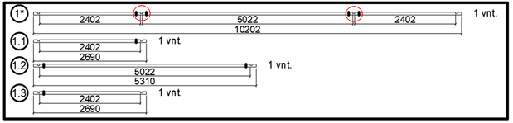

Step 1: Identify Connection Points
Look for the pre-cut connection points on your log pieces. These connection areas are typically marked or easily identifiable on the logs.

Step 2: Align and Join
- Position the log pieces so the connections align properly
- Fit the pieces together at the connection points
- Ensure a snug, secure fit

Step 3: Secure with Screws
- Insert screws through the designated holes
- Tighten screws to secure the connection
- Check that the joint is stable and properly aligned

Special Case: Uncut 65.5mm Logs
In rare instances, 65.5mm height logs may arrive with uncut log joints that require manual preparation.
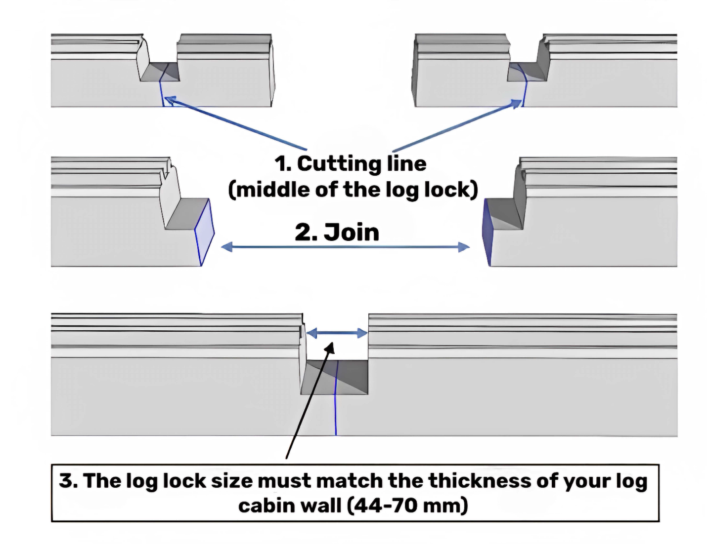

65.5 mm height wall log connection – 1. Cutting line (must be in the middle of the log lock); 2. Join both cut parts; 3. The final log lock size must match the thickness of your cabin wall (44-70 mm) – please always check and cut these marked parts if required.

Cutting Instructions
Step 1: Mark the Cutting Line
- Locate the center of the log lock
- Mark a cutting line exactly in the middle of the log lock
Step 2: Make the Cut
- Cut along the marked line using appropriate tools
- Ensure the cut is straight and clean
Step 3: Join the Cut Parts
- Align the two cut sections
- Test fit the pieces together

Critical Measurement Check
Final Size Verification:
- The completed log lock must match your cabin wall thickness
- Acceptable range: 44-70mm
- Always measure and verify before final assembly
- Trim if necessary to achieve proper fit

Quality Control
- Double-check all connections before proceeding
- Ensure all joints are secure and properly aligned
- Verify that log lock dimensions match your cabin specifications

Tools You May Need
- Measuring tape or ruler
- Saw (if cutting is required)
- Screwdriver or drill
- Screws (as specified in your kit)

Safety Notes
- Always wear appropriate safety equipment when cutting
- Take accurate measurements to avoid mistakes
- Test fit pieces before final assembly

